Lab 12
Intro to NextGen Firewalls
Cisco FirePower
Objective:
The purpose of this lab is for the student to understand configuration and implement NextGen Firewall rules and basic configuration
Lab Diagram:

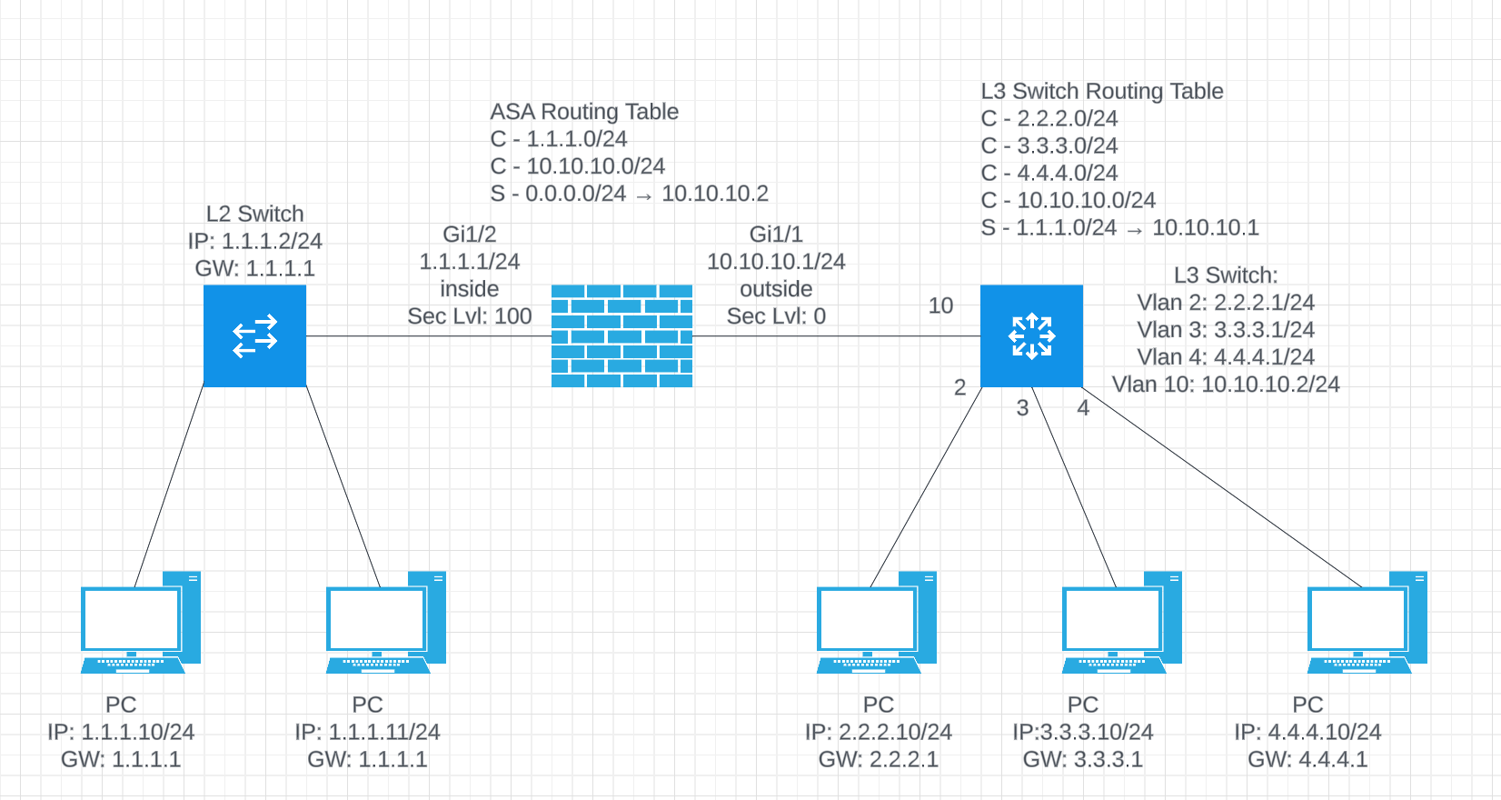

Admin Diagram
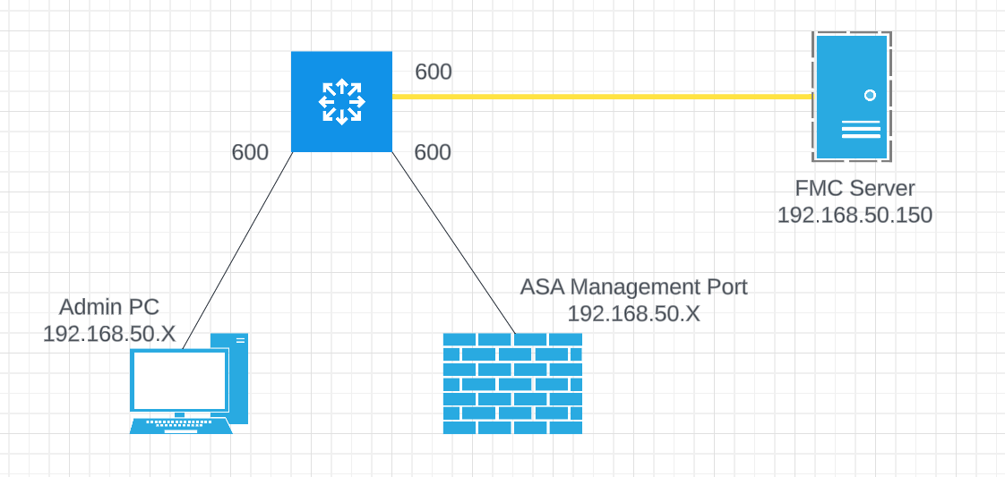

Components:
4 – PCs
1 – Cisco 5516X ASA
1 – Cisco 3650 L3 Switch
1 – Cisco 3650 L2 Switch

Useful commands for this lab
ASA Interface and Routing Config
interface gig 1/1
nameif inside
ip address 1.1.1.1 255.255.255.0
no shutdown
security-level 100

interface gi 1/2
nameif outside
ip address 10.10.10.1 255.255.255.0
no shutdown
security-level 0

route outside 0.0.0.0 0.0.0.0 10.10.10.2

Redirect Traffic to FirePower Module
class global-class
match any

policy-map global_policy
class glocal-class
sfr fail-open

Procedure:
- For this lab, we’ll need to use specific ASA firewalls. We only have the Firepower Module installed on the following ASAs:
  - Pod 1: Lab Station at PC 3 and 4
  - Pod 2: Lab Station at PC 9 and 10
  - Pod 3: Lab station at PC 15 and 16
- Choose one of the PCs near your ASA to be your admin PC. Configure the IP on the PC to be the following:
  - Pod 1: 192.168.50.201/24 – No Gateway
  - Pod 2: 192.168.50.202/24 – No Gateway
  - Pod 3: 192.168.50.203/24 – No Gateway
- Configure 3 ports on the switch near the ASA shown in Step 1 in VLAN 600. It doesn’t matter which 3 ports you choose.
  - Connect your ASA’s Management port to Vlan 600.
  - Connect the PCs you configured in step 2 to Vlan 600
  - Connect the yellow ethernet cable coming down from the ladder rack on the ceiling to Vlan 600
- Make sure your ASA’s Management port is enabled (no shutdown)
  - Connect to ASA via console
enable
Configure terminal
Interface management 1/1
No shutdown
- The Firepower modules on each ASA are already configured with an IP address. Each Pod’s FP Module has a unique IP, and you’ll only be able to ping your own Firepower module even though they’re on the same subnet. Once your admin PC is connected and configured and your devices are all connected to Vlan 600, confirm you can ping from the PC to the following before continuing to the next step.
  - Firepower Management Center – 192.168.50.150
  - Firepower Module (only ping the IP in your pod)
    - Pod 1 – 192.168.50.241
    - Pod 2 – 192.168.50.242
    - Pod 3 - 192.168.50.243
- Connect all PCs, switches and routers as shown in the diagram above.
- Use the configuration provided above in the commands section on the ASA
- If you want/need help with the L3 switch, let me know. I want more time spent in the FMC GUI than setting up the physical network.

- Connect to the GUI on your management PC using https://192.168.50.150. I will set up the connection to this network since it’s on the virtual servers in the rack. We’re all using the same Management server, but I set up different users for each pod. Please do not edit any other group’s policies. Pod 1 is by the door. Pod 3 is by the closet. Pod 2 is diagonal from where I sit.

  - Pod1 credentials: netc230pod1\Netcom339
  - Pod2 credentials netc230pod2\Netcom339
  - Pod2 credentials netc230pod3\Netcom339
- Once connected, look around at the different widgets on the Dashboard. List 3 of the widgets below (there are several):
  - Appliance Status
  - Current Sessions
  - System Load
- Under the Dashboard menu, choose status:
  - What version of code is the FMC running? 6.4.0.9
  - What version of code shows for the FirePower devices? 6.4.0.9 and 6.2.2
- Click on System on the top right and choose Tools
  - What tools do you have available to you? Backup/Restore, Scheduling, Import/Export, Data Purge
- Click on the Monitor option under system.
  - What monitor options are available to you? Audit, Syslog, Statistics
- From the menu on the top left, click on policies.
  - What policies are available under the first drop down? Access Control, Network Discovery, Application Detectors, Correlation, and Actions
- Hover the mouse over Access-Policy.
  - What additional Policies are available to you? Access Control, Intrusion, Malware & File, DNS, Identity, SSL, Prefilter
- Click on Access Policy
  - Create a new policy called NETC230Pod1, NETC230Pod2, or NETC230Pod3. Only create one policy for your respective pod.
  - Add a new rule to your policy that permits traffic from any source to any destination. The applications should be SSH, HTTPS and SNMP. enable logging on your rule to log at the beginning and end of your connection. You should see a logging tab in the rule.
  - Create another rule to permit traffic from 1.1.1.0/24 to 3.3.3.0/24 via tcp/3389. Use the service tab this time. enable logging on your rule to log at the beginning and end of your connection.
  - Screen shot your rules and paste below.
- Draw the lab diagram below (PCs, firewall and switch connections) Label the IP addresses, subnet masks, and gateways used by each device. Label all components, including your FMC and FPMs (manager and module).
